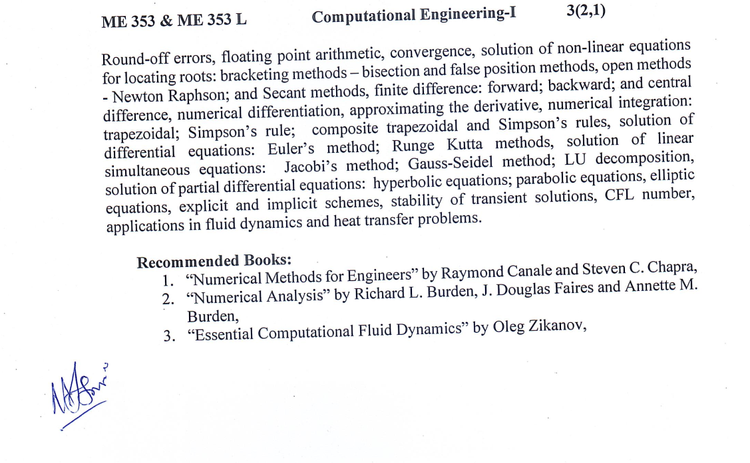

Lab 1: MATLAB Basics, Numerical Errors, Convergence and plotting
This laboratory session introduces students to the MATLAB environment and its use for numerical computation, visualization, and basic programming. Students will learn how to work with scripts and functions, define variables, vectors, and matrices, use control structures (loops and conditional statements), generate 2D and 3D plots, visualize data using histograms, and understand numerical errors and convergence through Taylor series approximation of mathematical functions.
Lab 2: Root Finding – Bisection Method
Implementation of the bisection method for solving nonlinear equations.
Effect of tolerance and initial bracket on convergence will be studied.
Results will be visualized using iteration history plots.
Lab 3: Root Finding – False Position Method
Students will implement the false position (regula falsi) method in MATLAB.
Comparison with the bisection method in terms of convergence speed.
Limitations of the method will be discussed.
Lab 4: Open Root-Finding Methods – Newton–Raphson
Implementation of the Newton–Raphson method for nonlinear equations.
Influence of initial guess and derivative calculation on convergence.
Cases of divergence and slow convergence will be demonstrated.
Lab 5: Open Root-Finding Methods – Secant Method
MATLAB implementation of the secant method without explicit derivative evaluation.
Comparison with Newton–Raphson regarding efficiency and robustness.
Application to engineering nonlinear equations.
Lab 6: Numerical Differentiation Using Finite Differences
Forward, backward, and central difference schemes will be implemented.
Accuracy and truncation error will be analyzed using analytical comparisons.
Effect of step size on numerical derivatives will be visualized.
Lab 7: Numerical Integration – Trapezoidal Rule
Implementation of single and composite trapezoidal rules.
Influence of step size on integration accuracy will be studied.
Engineering-based integral examples will be used.
Lab 8: Numerical Integration – Simpson’s Rule
Implementation of Simpson’s 1/3 and composite Simpson’s rules.
Accuracy comparison with trapezoidal rule for smooth functions.
Discussion on applicability and limitations.
Lab 9: Solution of ODEs – Euler’s Method
Numerical solution of first-order ordinary differential equations using Euler’s method.
Effect of time step on accuracy and stability will be demonstrated.
Comparison with analytical solutions where available.
Lab 10: Solution of ODEs – Runge–Kutta Methods
Implementation of second- and fourth-order Runge–Kutta methods.
Accuracy and stability comparison with Euler’s method.
Application to basic physical systems.
Lab 11: Solution of Linear Systems – Jacobi Method
Solution of systems of linear equations using the Jacobi iterative method.
Convergence conditions and diagonal dominance will be investigated.
Iteration history and error reduction will be visualized.
Lab 12: Linear Systems – Gauss–Seidel Method and LU Decomposition
Implementation of Gauss–Seidel iterative method and direct LU decomposition.
Comparison of iterative and direct solution approaches.
Discussion on computational efficiency and numerical stability.
Lab 13: Numerical Solution of PDEs and Engineering Applications
Basic finite difference methods for partial differential equations will be introduced.
Explicit and implicit schemes will be implemented in a simple form.
Applications to one-dimensional heat transfer and basic fluid flow problems will be demonstrated

